**Biology Revision: Plant Structures**

Mastery Matrix Points

|  |
| --- |
| Draw and label an unspecialised plant cell and a palisade, root hair, xylem and phloem specialised cell |
| Describe the 5 tissues and name the key organs in the plant |
| Label a transverse section of a leaf |
| Describe the process of osmosis |
| Calculate the rate of water uptake by a plant |
| Calculate the percentage change in mass following osmosis |
| Analyse and draw graphs relating to osmosis |
| **Required practical: Analyse the range of concentrations of solutions on the change in mass of plant tissue** |
| Describe the process of active transport and explain why it is necessary |
| Compare diffusion, osmosis and active transport |
| Describe the process of active transport and how root hair cells are adapted to this |
| Describe the process of transpiration and translocation (including the structure and function of stomata). |
| Explain the effect of changing temperature, humidity, air movement and light intensity on the rate of transpiration |
| Calculate surface area, volume and mean in transpiration investigation |
| Analyse data from graphs and tables relating to transpiration experiments |
| Describe in detail the location, function and adaptations of xylem tissue, phloem tissue, stomata and guard cells |

Key Knowledge

*Function of these plant tissues:*

epidermal tissue

palisade mesophyll

spongy mesophyll

xylem

phloem

meristem tissue

*Label the leaf tissues:*

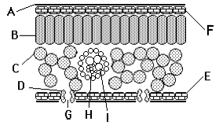

*How are these adapted to their job?*

Root hair cells

Xylem

Phloem

Guard cells

Definitions:

Osmosis

Active transport

Transpiration

Translocation

Calculations

rate of water uptake =

% change in mass =

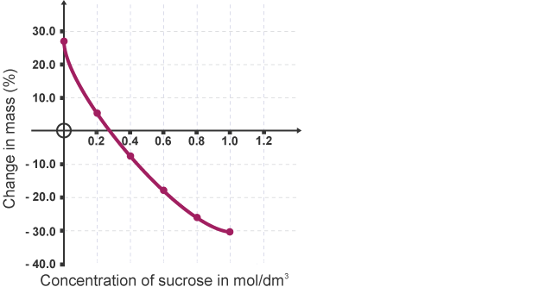

Understanding and Explaining

1. A student completes an osmosis experiment using potato cylinders. Describe how you could work out the concentration of the sucrose in the potato using their results graph.
2. Describe how active transport works.
3. In root hairs cells, water and nutrients move into the plant. How do the nutrients move into the cell? By what process does the water move into the cell?
4. Compare the processes of osmosis and active transport.
5. Describe and explain three factors that affect transpiration.
6. Describe two examples of active transport.